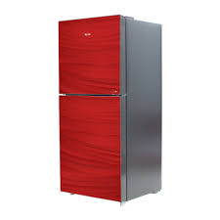

***Haier 9173WB Avante+ Sapphire Double Door Refrigerator***

* **Color:**Red
* **Available:**in stock
* **Dimension:**1641*595*600
* **Compressor:**Inverter

**Old Price:**~~Rs 201,999.00~~

**New Price:**Rs 101,999.00 (5%)